**Project Design Phase-II**

**Data Flow Diagram & User Stories**

| Date | 15 October 2022 |
| --- | --- |
| Team ID | PNT2022TMID33851 |
| Project Name | Project - Real time river water quality monitoring and control system |
| Maximum Marks | 4 Marks |

**Data Flow Diagrams:**

A Data Flow Diagram (DFD) is a traditional visual representation of the information flows within a system. A neat and clear DFD can depict the right amount of the system requirement graphically. It shows how data enters and leaves the system, what changes the information, and where data is stored.

**Example:** [**(Simplified)**](https://developer.ibm.com/patterns/visualize-unstructured-text/)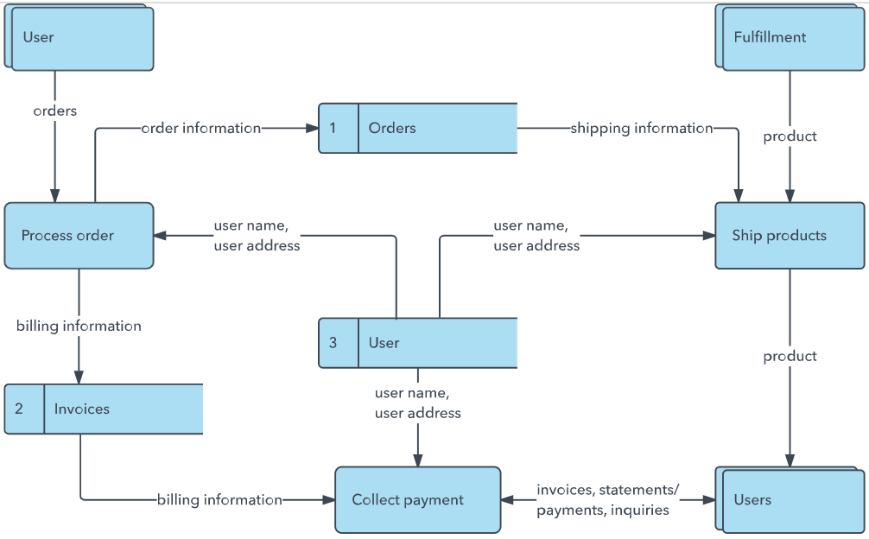

**User Stories**

Use the below template to list all the user stories for the product.

| **User Type** | **Functional Requirement (Epic)** | **User Story Number** | **User Story / Task** | **Acceptance criteria** | **Priority** | **Release** |
| --- | --- | --- | --- | --- | --- | --- |
| Customer (Mobile user) | Registration | USN-1 | As a user, I can register for the application by entering my email, password, and confirming my password. | I can access my account / dashboard | High | Sprint-1 |
|  |  | USN-2 | As a user, I will receive confirmation email once I have registered for the application | I can receive confirmation email & click confirm | High | Sprint-1 |
|  |  | USN-3 | As a user, I can register for the application through Facebook | I can register & access the dashboard with Facebook Login | Low | Sprint-2 |
|  |  | USN-4 | As a user, I can register for the application through Gmail | I can register & access the dashboard with gmail login | Medium | Sprint-1 |
|  | Login | USN-5 | As a user, I can log into the application by entering email & password | I can register & access the dashboard with email login | High | Sprint-1 |
|  | Dashboard | USN-6 | As a user, after login to the ibm account, click on dashboard | I can watch the videos and use the templates | High | Sprint-1 |
| Customer (Web user) | Login and dashboard | USN-7 | As a user, I can login to the application by gmail and after login to the ibm account click on dashboard | I can login to the app using the same email and password and access the resources. | High | Sprint-1 |
| Customer Care Executive | Login | CCE-1 | As a CCE I can login to app using my id and password and I can interact with user | I can login using my mail and password | High | Sprint-1 |
| Administrator | Login and dashboard | A1 | As an administrator, I can login and access dashboard and manage and direct activities. | I can login using my company id and password | High | Sprint-1 |
|  |  |  |  |  |  |  |
|  |  |  |  |  |  |  |
|  |  |  |  |  |  |  |